3dimensional jagged array
Eg: Array_3D_jagged
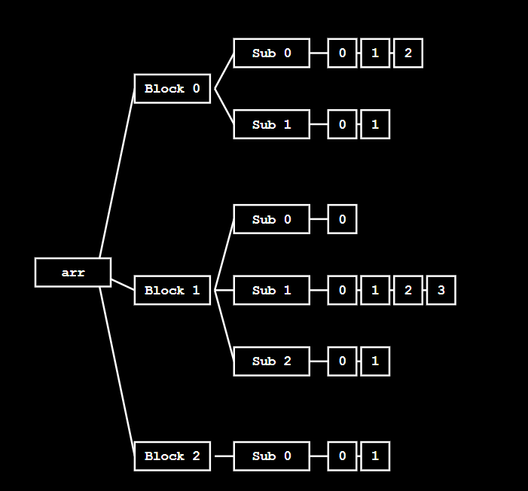

🔹 Given 3D Jagged Array (Target Structure)
We want the loops to finally create this exact structure:
int[][][] arr = {
{ {10, 11, 12}, {20, 21} },
{ {30}, {40, 41, 42, 43}, {50, 51} },
{ {60, 61} }
};

🔹 Meaning of This Structure
First dimension (outer) size = 3

arr[0] → 2 inner arrays
arr[1] → 3 inner arrays
arr[2] → 1 inner array

Inner sizes:
arr[0][0] → 3 elements
arr[0][1] → 2 elements

arr[1][0] → 1 element
arr[1][1] → 4 elements
arr[1][2] → 2 elements

arr[2][0] → 2 elements

🔹 Loops Under Discussion
for (int i = 0; i < colleges; i++) {

int classes = sc.nextInt();
arr[i] = new int[classes][];

for (int j = 0; j < classes; j++) {

int students = sc.nextInt();
arr[i][j] = new int[students];
}
}
So:
colleges = 3

🔸 Initial State (Before Loops)
arr → [ null , null , null ]

Memory now:
arr →
[
null,
null,
null
]

🔁 OUTER LOOP : Iteration – 0
int i = 0 ; i (0) < 3 → true

classes = 2
(because arr[0] has 2 inner arrays)
arr[0] = new int[2][]

Memory now:
arr →
[
[ null , null ],
null,
null
]

inner loop : iteration – 0
j = 0 ; j (0) < 2 → true

students = 3
(because arr[0][0] has 3 elements)
arr[0][0] = {10, 11, 12}

Memory now:
arr →
[
[
[ 10 , 11 , 12 ],
null
],
null,
null
]

inner loop : iteration – 1
j = 1 ; j (1) < 2 → true

students = 2
(because arr[0][1] has 2 elements)
arr[0][1] = {20, 21}

Memory now:
arr →
[
[
[ 10 , 11 , 12 ],
[ 20 , 21 ]
],
null,
null
]

inner loop : iteration – 2
j = 2 ; j (2) < 2 → false
➡️ inner loop condition failed
➡️ control comes to outer loop

🔁 OUTER LOOP : Iteration – 1
int i = 1 ; i (1) < 3 → true

classes = 3
(because arr[1] has 3 inner arrays)
arr[1] = new int[3][]

Memory now:
arr →
[
[
[ 10 , 11 , 12 ],
[ 20 , 21 ]
],
[ null , null , null ],
null
]

inner loop : iteration – 0
j = 0 ; j (0) < 3 → true

students = 1
(because arr[1][0] has 1 element)
arr[1][0] = {30}

Memory now:
arr →
[
[
[ 10 , 11 , 12 ],
[ 20 , 21 ]
],
[
[ 30 ],
null,
null
],
null
]

inner loop : iteration – 1
j = 1 ; j (1) < 3 → true

students = 4
(because arr[1][1] has 4 elements)
arr[1][1] = {40, 41, 42, 43}

Memory now:
arr →
[
[
[ 10 , 11 , 12 ],
[ 20 , 21 ]
],
[
[ 30 ],
[ 40 , 41 , 42 , 43 ],
null
],
null
]

inner loop : iteration – 2
j = 2 ; j (2) < 3 → true

students = 2
(because arr[1][2] has 2 elements)
arr[1][2] = {50, 51}

Memory now:
arr →
[
[
[ 10 , 11 , 12 ],
[ 20 , 21 ]
],
[
[ 30 ],
[ 40 , 41 , 42 , 43 ],
[ 50 , 51 ]
],
null
]

inner loop : iteration – 3
j = 3 ; j (3) < 3 → false
➡️ inner loop condition failed
➡️ control comes to outer loop

🔁 OUTER LOOP : Iteration – 2
int i = 2 ; i (2) < 3 → true

classes = 1
(because arr[2] has 1 inner array)
arr[2] = new int[1][]

Memory now:
arr →
[
[
[ 10 , 11 , 12 ],
[ 20 , 21 ]
],
[
[ 30 ],
[ 40 , 41 , 42 , 43 ],
[ 50 , 51 ]
],
[ null ]
]

inner loop : iteration – 0
j = 0 ; j (0) < 1 → true

students = 2
(because arr[2][0] has 2 elements)
arr[2][0] = {60, 61}

Memory now:
arr →
[
[
[ 10 , 11 , 12 ],
[ 20 , 21 ]
],
[
[ 30 ],
[ 40 , 41 , 42 , 43 ],
[ 50 , 51 ]
],
[
[ 60 , 61 ]
]
]

inner loop : iteration – 1
j = 1 ; j (1) < 1 → false
➡️ inner loop condition failed
➡️ control comes to outer loop

🔁 OUTER LOOP : Iteration – 3
int i = 3 ; i (3) < 3 → false
➡️ outer loop condition failed
➡️ outer loop ends

✅ FINAL MEMORY STATE (WITH ACTUAL VALUES)
arr →
[
[ [10,11,12], [20,21] ],
[ [30], [40,41,42,43], [50,51] ],
[ [60,61] ]
]

📌 Important Note (Very Important for Understanding)
In the above explanation, the numbers shown inside the array are only for understanding and visualization purpose.
Up to these two for loops, we are NOT storing actual values into the array.
These loops are used only to create the 3-dimensional jagged structure (first level, second level, and third level arrays).
The real values will be stored later using another separate set of for loops, which will be shown next.

🧠 One-Line Core Truth (Interview Friendly)
First set of loops creates the jagged array structure; a separate set of loops is required to store actual values.

for (int i = 0; i < arr.length; i++) {

// arr[i] represents one second-level group
for (int j = 0; j < arr[i].length; j++) {

// arr[i][j] represents one third-level array
for (int k = 0; k < arr[i][j].length; k++) {

/*
arr[i][j][k] access order:
- first select first-level reference
- then select second-level reference
- then store value at deepest level
*/
System.out.print(
"Enter marks for college " + i +
", class " + j +
", student " + k + ": ");

arr[i][j][k] = sc.nextInt();
}
}
}

🔸 Initial State (Before Value Insertion Loops)
Structure already exists, but values are not yet stored.

Memory now:
arr →
[
[ [ _ , _ , _ ], [ _ , _ ] ],
[ [ _ ], [ _ , _ , _ , _ ], [ _ , _ ] ],
[ [ _ , _ ] ]
]
(_ means empty / not assigned yet)

🔁 1️⃣ OUTERMOST LOOP

Step 1
i = 0 ; i (0) < 3 → true
➡️ control goes to middle loop

🔁 2️⃣ MIDDLE LOOP (for i = 0)

Step 2
j = 0 ; j (0) < 2 → true
➡️ control goes to inner loop

🔁 3️⃣ INNER LOOP (for i = 0, j = 0)

Step 3
k = 0 ; k (0) < 3 → true
arr[0][0][0] = 10

Memory now:
arr →
[
[ [ 10 , _ , _ ], [ _ , _ ] ],
[ [ _ ], [ _ , _ , _ , _ ], [ _ , _ ] ],
[ [ _ , _ ] ]
]

Step 4
k = 1 ; k (1) < 3 → true
arr[0][0][1] = 11

Memory now:
arr →
[
[ [ 10 , 11 , _ ], [ _ , _ ] ],
[ [ _ ], [ _ , _ , _ , _ ], [ _ , _ ] ],
[ [ _ , _ ] ]
]

Step 5
k = 2 ; k (2) < 3 → true
arr[0][0][2] = 12

Memory now:
arr →
[
[ [ 10 , 11 , 12 ], [ _ , _ ] ],
[ [ _ ], [ _ , _ , _ , _ ], [ _ , _ ] ],
[ [ _ , _ ] ]
]

Step 6
k = 3 ; k (3) < 3 → false
➡️ inner loop ends
➡️ control goes to middle loop

🔁 2️⃣ MIDDLE LOOP (for i = 0)

Step 7
j = 1 ; j (1) < 2 → true
➡️ control goes to inner loop

🔁 3️⃣ INNER LOOP (for i = 0, j = 1)

Step 8
k = 0 ; k (0) < 2 → true
arr[0][1][0] = 20

Memory now:
arr →
[
[ [ 10 , 11 , 12 ], [ 20 , _ ] ],
[ [ _ ], [ _ , _ , _ , _ ], [ _ , _ ] ],
[ [ _ , _ ] ]
]

Step 9
k = 1 ; k (1) < 2 → true
arr[0][1][1] = 21

Memory now:
arr →
[
[ [ 10 , 11 , 12 ], [ 20 , 21 ] ],
[ [ _ ], [ _ , _ , _ , _ ], [ _ , _ ] ],
[ [ _ , _ ] ]
]

Step 10
k = 2 ; k (2) < 2 → false
➡️ inner loop ends
➡️ control goes to middle loop

Step 11
j = 2 ; j (2) < 2 → false
➡️ middle loop ends
➡️ control goes to outer loop

🔁 1️⃣ OUTERMOST LOOP

Step 12
i = 1 ; i (1) < 3 → true
➡️ control goes to middle loop

🔁 2️⃣ MIDDLE LOOP (for i = 1)

Step 13
j = 0 ; j (0) < 3 → true
➡️ control goes to inner loop

🔁 3️⃣ INNER LOOP (for i = 1, j = 0)

Step 14
k = 0 ; k (0) < 1 → true
arr[1][0][0] = 30

Memory now:
arr →
[
[ [ 10 , 11 , 12 ], [ 20 , 21 ] ],
[ [ 30 ], [ _ , _ , _ , _ ], [ _ , _ ] ],
[ [ _ , _ ] ]
]

Step 15
k = 1 ; k (1) < 1 → false
➡️ inner loop ends
➡️ control goes to middle loop

🔁 2️⃣ MIDDLE LOOP (for i = 1)

Step 16
j = 1 ; j (1) < 3 → true
➡️ control goes to inner loop

🔁 3️⃣ INNER LOOP (for i = 1, j = 1)
arr[1][1][0] = 40
arr[1][1][1] = 41
arr[1][1][2] = 42
arr[1][1][3] = 43

Memory now:
arr →
[
[ [ 10 , 11 , 12 ], [ 20 , 21 ] ],
[ [ 30 ], [ 40 , 41 , 42 , 43 ], [ _ , _ ] ],
[ [ _ , _ ] ]
]

🔁 Continue (same flow)
arr[1][2][0] = 50
arr[1][2][1] = 51

Memory now:
arr →
[
[ [ 10 , 11 , 12 ], [ 20 , 21 ] ],
[ [ 30 ], [ 40 , 41 , 42 , 43 ], [ 50 , 51 ] ],
[ [ _ , _ ] ]
]

🔁 OUTERMOST LOOP (i = 2)
arr[2][0][0] = 60
arr[2][0][1] = 61

Memory now:
arr →
[
[ [ 10 , 11 , 12 ], [ 20 , 21 ] ],
[ [ 30 ], [ 40 , 41 , 42 , 43 ], [ 50 , 51 ] ],
[ [ 60 , 61 ] ]
]

✅ FINAL MEMORY STATE (After Value Insertion)
arr →
[
[ [10,11,12], [20,21] ],
[ [30], [40,41,42,43], [50,51] ],
[ [60,61] ]
]

Eg: Array_3D_Jagged_Eg2
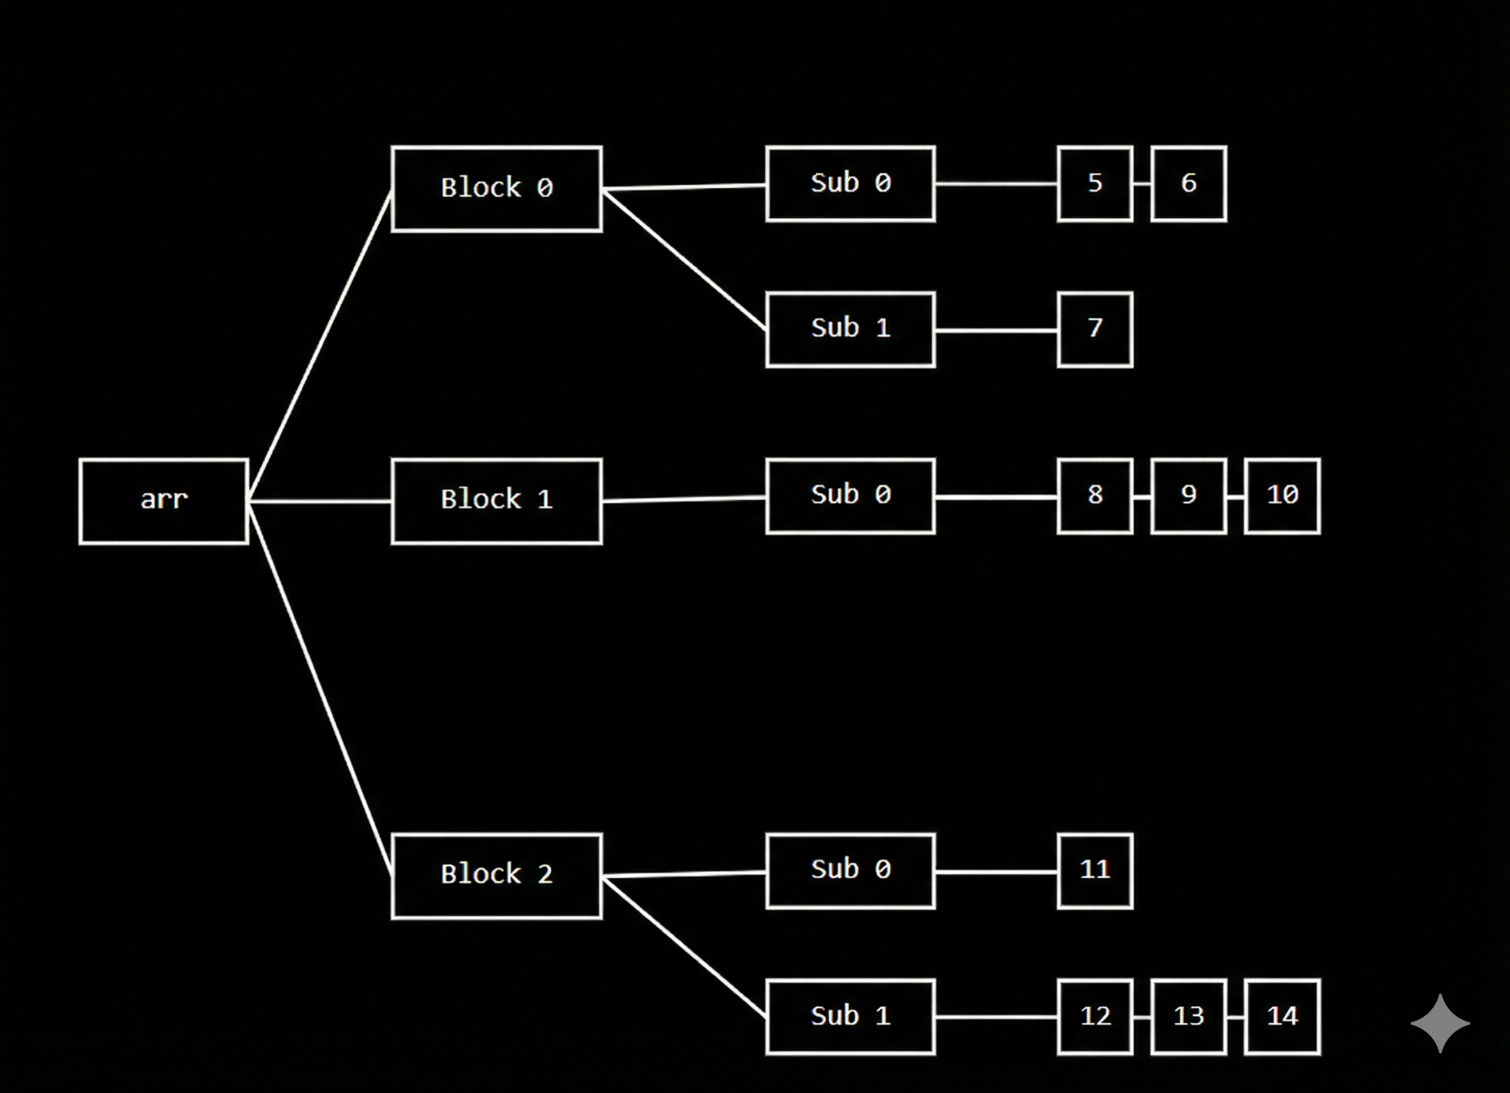

🔹 Given 3D Jagged Array (Target Structure)
We want the loops to finally create this exact structure:
int[][][] arr = {
{ {5, 6}, {7} },
{ {8, 9, 10} },
{ {11}, {12, 13, 14} }
};

🔹 Meaning of This Structure
First dimension (outer) size = 3
arr[0] → 2 inner arrays
arr[1] → 1 inner array
arr[2] → 2 inner arrays
Inner sizes:
arr[0][0] → 2 elements
arr[0][1] → 1 element

arr[1][0] → 3 elements

arr[2][0] → 1 element
arr[2][1] → 3 elements

🔹 Loops Under Discussion
// Create the outermost array
int[][][] arr = new int[colleges][][];

// Step 2: Take the number of classes for each college
for (int i = 0; i < colleges; i++) {
int classes = sc.nextInt();
arr[i] = new int[classes][];
}

// Step 3: Take the number of students for each class
for (int i = 0; i < arr.length; i++) {
for (int j = 0; j < arr[i].length; j++) {
int students = sc.nextInt();
arr[i][j] = new int[students];
}
}
So:
colleges = 3

🔸 Initial State (Before Loops)
arr → [ null , null , null ]
Memory now:
arr →
[
null,
null,
null
]

🔁 OUTER LOOP : Iteration – 0
int i = 0 ; i (0) < 3 → true
classes = 2
(because arr[0] has 2 inner arrays)
arr[0] = new int[2][]
Memory now:
arr →
[
[ null , null ],
null,
null
]

inner loop : iteration – 0
j = 0 ; j (0) < 2 → true
students = 2
(because arr[0][0] has 2 elements)
arr[0][0] = {5, 6}
Memory now:
arr →
[
[
[ 5 , 6 ],
null
],
null,
null
]

inner loop : iteration – 1
j = 1 ; j (1) < 2 → true
students = 1
(because arr[0][1] has 1 element)
arr[0][1] = {7}
Memory now:
arr →
[
[
[ 5 , 6 ],
[ 7 ]
],
null,
null
]

inner loop : iteration – 2
j = 2 ; j (2) < 2 → false
➡️ inner loop condition failed
➡️ control comes to outer loop

🔁 OUTER LOOP : Iteration – 1
int i = 1 ; i (1) < 3 → true
classes = 1
(because arr[1] has 1 inner array)
arr[1] = new int[1][]
Memory now:
arr →
[
[
[ 5 , 6 ],
[ 7 ]
],
[ null ],
null
]

inner loop : iteration – 0
j = 0 ; j (0) < 1 → true
students = 3
(because arr[1][0] has 3 elements)
arr[1][0] = {8, 9, 10}
Memory now:
arr →
[
[
[ 5 , 6 ],
[ 7 ]
],
[
[ 8 , 9 , 10 ]
],
null
]

inner loop : iteration – 1
j = 1 ; j (1) < 1 → false
➡️ inner loop condition failed
➡️ control comes to outer loop

🔁 OUTER LOOP : Iteration – 2
int i = 2 ; i (2) < 3 → true
classes = 2
(because arr[2] has 2 inner arrays)
arr[2] = new int[2][]
Memory now:
arr →
[
[
[ 5 , 6 ],
[ 7 ]
],
[
[ 8 , 9 , 10 ]
],
[ null , null ]
]

inner loop : iteration – 0
j = 0 ; j (0) < 2 → true
students = 1
(because arr[2][0] has 1 element)
arr[2][0] = {11}
Memory now:
arr →
[
[
[ 5 , 6 ],
[ 7 ]
],
[
[ 8 , 9 , 10 ]
],
[
[ 11 ],
null
]
]

inner loop : iteration – 1
j = 1 ; j (1) < 2 → true
students = 3
(because arr[2][1] has 3 elements)
arr[2][1] = {12, 13, 14}
Memory now:
arr →
[
[
[ 5 , 6 ],
[ 7 ]
],
[
[ 8 , 9 , 10 ]
],
[
[ 11 ],
[ 12 , 13 , 14 ]
]
]

inner loop : iteration – 2
j = 2 ; j (2) < 2 → false
➡️ inner loop condition failed
➡️ control comes to outer loop

🔁 OUTER LOOP : Iteration – 3
int i = 3 ; i (3) < 3 → false
➡️ outer loop condition failed
➡️ outer loop ends

✅ FINAL MEMORY STATE (WITH ACTUAL VALUES)
arr →
[
[ [5,6], [7] ],
[ [8,9,10] ],
[ [11], [12,13,14] ]
]

📌 Important Note (Very Important for Understanding)
In the above explanation, the numbers shown inside the array are only for understanding and visualization purpose.
Up to these two for loops, we are NOT storing actual values from the user.
These loops are used only to create the 3-dimensional jagged structure
(first level, second level, and third level arrays).
The real values will be stored later using another separate set of for loops.

🧠 One-Line Core Truth (Interview Friendly)
First set of loops creates the jagged array structure; a separate set of loops is required to store actual values.

🔹 Loops Under Discussion (Value Insertion)
// Step 4: Enter marks for each student
for (int i = 0; i < arr.length; i++) { // colleges
for (int j = 0; j < arr[i].length; j++) { // classes
for (int k = 0; k < arr[i][j].length; k++) { // students
System.out.println(
"Enter marks for College " + i +
", Class " + j +
", Student " + k + ": ");
arr[i][j][k] = sc.nextInt();
}
}
}

🔸 Initial State (Before Value Insertion Loops)
Structure already exists, but values are not yet stored.
Memory now:
arr →
[
[ [ _ , _ ], [ _ ] ],
[ [ _ , _ , _ ] ],
[ [ _ ], [ _ , _ , _ ] ]
]
(_ means empty / not assigned yet)

🔁 1️⃣ OUTERMOST LOOP

Step 1
i = 0 ; i (0) < 3 → true
➡️ control goes to middle loop

🔁 2️⃣ MIDDLE LOOP (for i = 0)

Step 2
j = 0 ; j (0) < 2 → true
➡️ control goes to inner loop

🔁 3️⃣ INNER LOOP (for i = 0, j = 0)

Step 3
k = 0 ; k (0) < 2 → true
arr[0][0][0] = 5
Memory now:
arr →
[
[ [ 5 , _ ], [ _ ] ],
[ [ _ , _ , _ ] ],
[ [ _ ], [ _ , _ , _ ] ]
]

Step 4
k = 1 ; k (1) < 2 → true
arr[0][0][1] = 6
Memory now:
arr →
[
[ [ 5 , 6 ], [ _ ] ],
[ [ _ , _ , _ ] ],
[ [ _ ], [ _ , _ , _ ] ]
]

Step 5
k = 2 ; k (2) < 2 → false
➡️ inner loop ends
➡️ control goes to middle loop

🔁 2️⃣ MIDDLE LOOP (for i = 0)

Step 6
j = 1 ; j (1) < 2 → true
➡️ control goes to inner loop

🔁 3️⃣ INNER LOOP (for i = 0, j = 1)

Step 7
k = 0 ; k (0) < 1 → true
arr[0][1][0] = 7
Memory now:
arr →
[
[ [ 5 , 6 ], [ 7 ] ],
[ [ _ , _ , _ ] ],
[ [ _ ], [ _ , _ , _ ] ]
]

Step 8
k = 1 ; k (1) < 1 → false
➡️ inner loop ends
➡️ control goes to middle loop

Step 9
j = 2 ; j (2) < 2 → false
➡️ middle loop ends
➡️ control goes to outer loop

🔁 1️⃣ OUTERMOST LOOP

Step 10
i = 1 ; i (1) < 3 → true
➡️ control goes to middle loop

🔁 2️⃣ MIDDLE LOOP (for i = 1)

Step 11
j = 0 ; j (0) < 1 → true
➡️ control goes to inner loop

🔁 3️⃣ INNER LOOP (for i = 1, j = 0)

Step 12
k = 0 ; k (0) < 3 → true
arr[1][0][0] = 8

Step 13
k = 1 ; k (1) < 3 → true
arr[1][0][1] = 9

Step 14
k = 2 ; k (2) < 3 → true
arr[1][0][2] = 10
Memory now:
arr →
[
[ [ 5 , 6 ], [ 7 ] ],
[ [ 8 , 9 , 10 ] ],
[ [ _ ], [ _ , _ , _ ] ]
]

Step 15
k = 3 ; k (3) < 3 → false
➡️ inner loop ends
➡️ control goes to middle loop

Step 16
j = 1 ; j (1) < 1 → false
➡️ middle loop ends
➡️ control goes to outer loop

🔁 1️⃣ OUTERMOST LOOP

Step 17
i = 2 ; i (2) < 3 → true
➡️ control goes to middle loop

🔁 2️⃣ MIDDLE LOOP (for i = 2)

Step 18
j = 0 ; j (0) < 2 → true
➡️ control goes to inner loop

🔁 3️⃣ INNER LOOP (for i = 2, j = 0)

Step 19
k = 0 ; k (0) < 1 → true
arr[2][0][0] = 11
Memory now:
arr →
[
[ [ 5 , 6 ], [ 7 ] ],
[ [ 8 , 9 , 10 ] ],
[ [ 11 ], [ _ , _ , _ ] ]
]

Step 20
k = 1 ; k (1) < 1 → false
➡️ inner loop ends
➡️ control goes to middle loop

🔁 2️⃣ MIDDLE LOOP (for i = 2)

Step 21
j = 1 ; j (1) < 2 → true
➡️ control goes to inner loop

🔁 3️⃣ INNER LOOP (for i = 2, j = 1)
arr[2][1][0] = 12
arr[2][1][1] = 13
arr[2][1][2] = 14
Memory now:
arr →
[
[ [ 5 , 6 ], [ 7 ] ],
[ [ 8 , 9 , 10 ] ],
[ [ 11 ], [ 12 , 13 , 14 ] ]
]

Step 22
j = 2 ; j (2) < 2 → false
➡️ middle loop ends
➡️ control goes to outer loop

🔁 OUTERMOST LOOP

Step 23
i = 3 ; i (3) < 3 → false
➡️ outermost loop ends

✅ FINAL MEMORY STATE (After Value Insertion)
arr →
[
[ [5,6], [7] ],
[ [8,9,10] ],
[ [11], [12,13,14] ]
]

📘 Core Concept: Arrays in Java (Primitive vs Reference)

🔹 1️⃣ Arrays Are Homogeneous (Most Important Point)
An array in Java can store only ONE type of data.
That one type can be:
- a primitive type (int, char, double, boolean, etc.)
- OR a reference type (objects of a class, interface, array, etc.)
👉 But never mixed.

🔹 2️⃣ What “Homogeneous” Really Means
If an array is declared as:
int[] arr;
Then:
- Every element must be an int
- You cannot store:
  - double
  - String
  - Object
  - any other type
Java enforces this at compile time.

🔹 3️⃣ Arrays of Primitive Types (Value Storage)

Example:
int[] arr = new int[5];

What happens internally:
- arr stores 5 integer values
- Each element directly holds a number
- Default value = 0
arr[0] = 10;
arr[1] = 20;

Core idea:
Primitive array stores actual values, not references.

🔹 4️⃣ Arrays of Objects (Reference Storage)

Example:
Student[] students = new Student[3];

Important internal truth:
- This array does NOT store Student objects
- It stores references to Student objects
Initially:
students → [ null , null , null ]
When you write:
students[0] = new Student("Pavan", 21);
What happens:
- A Student object is created in heap
- Its reference is stored in students[0]

🔹 5️⃣ Why Object Arrays Are Still Homogeneous
Even though objects have many fields:
String name;
int age;
The array type is still:
Student[]
So:
- Every element must be Student
- You cannot store:
  - Employee
  - String
  - Object (without casting)
  - Any other class
👉 Homogeneous means same reference type, not same data inside.

🔹 6️⃣ Primitive Array vs Object Array (Key Difference)
Aspect | Primitive Array | Object Array
What is stored | Actual values | References
Default value | 0 / false / '\0' | null
Memory | Continuous values | References → objects
Example | int[] | Student[]

🔹 7️⃣ Very Important Interview Line ⭐
Arrays in Java are homogeneous. They can store either primitives or references, but all elements must be of the same declared type.

🧠 Final Core Concept in One Sentence
A Java array is a fixed-size, homogeneous data structure that stores either primitive values directly or references to objects of the same type.

Eg: Array_Object_Type
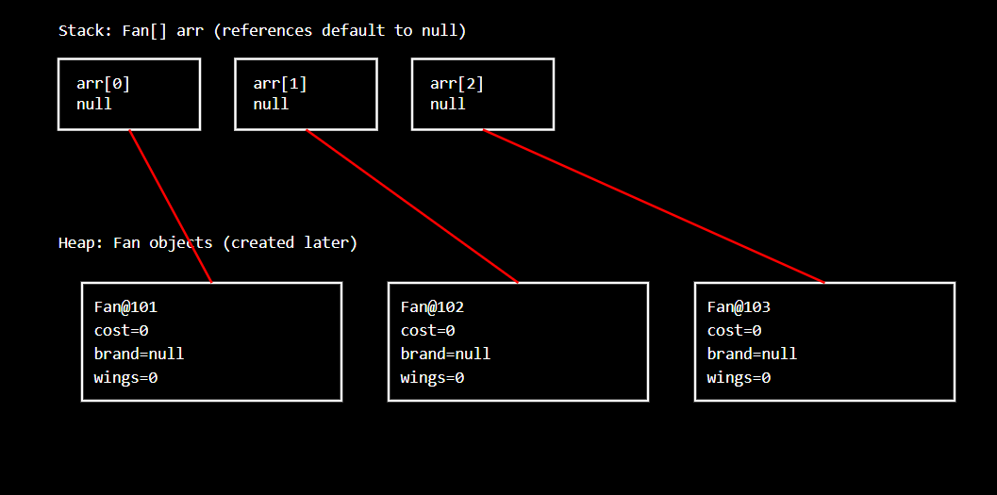

🔹 1️⃣ Arrays of Primitive Types
“If an array stores primitives, their default values are based on the data type.”
✔️ Correct
Examples:
int[] a = new int[3]; // [0, 0, 0]
double[] b = new double[2]; // [0.0, 0.0]
char[] c = new char[2]; // ['\u0000', '\u0000']
boolean[] d = new boolean[2]; // [false, false]
👉 Primitive arrays store actual values, so JVM assigns type-specific default values.

🔹 2️⃣ Arrays of Object (Reference) Types
“If an array stores object type, default value will be null for all types.”
✔️ Correct
Example:
Fan[] fans = new Fan[3];
Initial state:
fans → [ null , null , null ]
👉 Because:
- The array stores references
- No object is created yet
- Default value for any reference type = null
This applies to:
- Class objects
- Interface references
- Arrays of arrays
- Wrapper classes (Integer, Double, etc.)
- String

⚠️ Small Precision Point (Important)
The correct technical wording is:
The default value of a reference type is always null.
Not “object type” strictly — but reference type.
(Your meaning is correct; this is just terminology accuracy.)

🧠 Final Interview-Perfect Statement ⭐
In Java, arrays of primitive types are initialized with type-specific default values, while arrays of reference types are initialized with null references.

📘 Arrays and Contiguous Memory — Corrected Core Concept

1️⃣ What does contiguous memory REALLY mean?
Think of RAM as a long row of numbered seats 🎭.
When Java creates an array, it needs:
- one continuous block of memory
- all array elements must be placed next to each other
👉 This is what contiguous memory means.
⚠️ Important correction:
- This idea applies to the array itself
- NOT necessarily to the objects referenced by the array

2️⃣ Primitive Array (Fully Contiguous Data)

Example
int[] arr = new int[3];

What really happens
- Each int takes 4 bytes
- Total memory needed = 3 × 4 = 12 bytes
- JVM asks memory manager:
“Give me 12 bytes in one continuous block”
If memory manager finds:
[xxxx][xxxx][xxxx] ← continuous
➡️ Array is created
If memory looks like:
[xxxx] [ ] [xxxx] [ ] [xxxx]
➡️ Array cannot be created
✔️ Primitive array stores actual values contiguously

3️⃣ Reference Array (Contiguous references, NOT objects)

Example
Fan[] arr = new Fan[3];

❗ Important correction here
What is stored contiguously?
✅ Only the references (addresses)
❌ NOT the Fan objects

Memory reality
arr → [ ref , ref , ref ] ← contiguous
Later:
arr[0] = new Fan();
- new Fan() creates an object somewhere in heap
- That location does NOT need to be contiguous
- The array only stores the address
👉 Objects can be anywhere in heap memory
✔️ This is where your earlier explanation needed correction

4️⃣ Why does Java REQUIRE contiguous memory for arrays?

(Deep but Simple Explanation)

🔹 Core Idea (Before Example)
An array is designed for direct access, not searching.
That means:
Java must reach arr[i] immediately, without checking other elements.
This is only possible if array elements are stored next to each other in memory.

🔹 Think of Memory as Numbered Houses 🏠
Assume:
- Each int takes 4 bytes
- Array base address starts at 1000
int[] arr = new int[5];

Memory layout (contiguous):
Index | Address
arr[0] | 1000
arr[1] | 1004
arr[2] | 1008
arr[3] | 1012
arr[4] | 1016

🔹 How CPU Accesses arr[3]
CPU does one calculation:
address = baseAddress + (index × elementSize)
address = 1000 + (3 × 4)
address = 1012
➡️ CPU jumps directly to address 1012
✔️ No loop
✔️ No searching
✔️ No checking previous elements
⚡ This is O(1) constant-time access

🔹 What if elements were NOT contiguous? ❌
Imagine this (scattered memory):
Index | Address
arr[0] | 1000
arr[1] | 2500
arr[2] | 1800
arr[3] | 9999
Now try to access:
arr[3]

Problem:
- CPU cannot calculate address
- Formula no longer works
- JVM must:
  - store a separate address table
  - look up where index 3 is stored
This becomes:
Search → lookup → then access
❌ Slower
❌ More memory
❌ Complex
👉 Array loses its main advantage

🔹 Why Java DOES NOT allow this for arrays
Java says:
“If I cannot calculate the address directly, it is not an array.”
So Java enforces:
- Fixed size
- Contiguous storage
- Same element size
That guarantees:
- Fast access
- Simple memory math
- Predictable performance

🔹 Real-World Analogy 🚗

Contiguous (Array)
- Parking slots numbered in order
- Want slot 7?
- Directly go to slot 7

Non-contiguous (Linked list)
- Cars parked randomly
- To find 7th car:
  - Start from first
  - Move one by one
➡️ Much slower

🔑 Why LinkedList Exists Then?
LinkedList trades:
- ❌ Fast random access
- ✅ Easy insertion/deletion
Arrays trade:
- ❌ Fixed size
- ✅ Fast random access

✅ Final One-Line Truth (Interview Gold ⭐)
Arrays use contiguous memory so the JVM can compute element addresses directly, giving constant-time random access without searching.

🧠 Key Formula to Remember
arr[i] → baseAddress + (i × elementSize)
This formula ONLY works because of contiguous memory.

5️⃣ Very Important Clarification (Often Missed)
Case | Contiguous?
Primitive array values | ✅ Yes
Reference array slots | ✅ Yes
Actual objects | ❌ No
6.

📘 Arrays Utility Class — Core Concept (Simple & Deep)

1️⃣ Main goal of arrays in Java
Arrays in Java are made for one main purpose:
Store data and give very fast access to it.
To achieve this, arrays are kept:
- Simple
- Light in memory
- Very fast
That is why:
- Arrays use continuous memory
- Accessing arr[i] is very quick
👉 Speed is the main strength of arrays.

2️⃣ Why arrays do NOT have methods
If arrays had methods like normal objects:
arr.sort();
arr.search();
Then arrays would need:
- Extra internal details
- More memory
- More processing during creation
This would:
- Make arrays heavier
- Reduce speed
- Affect fast access
So Java intentionally keeps arrays very simple.
Arrays are meant only to:
- store values
- give access using index
They are not meant to do operations.

3️⃣ But operations are still required
Even though arrays are simple, we still need to:
- sort them
- search elements
- compare arrays
- copy arrays
So Java needed a way to support these operations without damaging array speed.

4️⃣ Java’s smart solution
Java follows this idea:
Keep arrays simple, move operations outside.
Instead of adding methods inside arrays, Java provides operations from another class.
That class is:
Arrays
This way:
- Arrays stay fast
- Operations still exist
- Array design is not disturbed

5️⃣ What exactly is the Arrays class?
The Arrays class:
- Does not store data
- Does not represent an object
- Only contains common operations for arrays
Example:
Arrays.sort(arr);
Here:
- arr stays the same type of array
- Only the operation is applied

6️⃣ Why are Arrays methods STATIC?
Now the most important part.
Ask these simple questions:

1️⃣ Arrays does not have instance variables
→ so it does not remember anything
Meaning in simple terms:
There is no data stored inside the Arrays class itself.
If Arrays had instance variables, it would look like this (but it does NOT):
class Arrays {
int lastIndex; // ❌ not present
}
Since there are no instance variables, nothing is remembered between calls.
Example:
int[] a = {3, 1, 2};
Arrays.sort(a);

int[] b = {9, 5, 6};
Arrays.sort(b);
✔️ Sorting b is not affected by sorting a
✔️ No previous data is remembered

2️⃣ Arrays does not store array data inside itself
→ it only works on the array you pass
Meaning in simple terms:
Arrays never keeps a copy of your array.
Example:
int[] arr = {4, 2, 8};

Arrays.sort(arr);
What happens:
- arr is passed to the method
- Sorting is done directly on arr
- Arrays does not save arr anywhere
After the method finishes:
arr → [2, 4, 8]
✔️ Data stays in the array
✔️ Arrays class holds nothing

3️⃣ Arrays uses the same logic for every array
→ behavior does not change per object
Meaning in simple terms:
The sorting logic is the same for all arrays of the same type.
Example:
int[] x = {7, 3, 9};
int[] y = {1, 8, 4};

Arrays.sort(x);
Arrays.sort(y);
✔️ Same sorting algorithm
✔️ No special behavior for different arrays
✔️ No need for different Arrays objects

🔹 Because of these reasons…
- No instance variables
- No stored data
- Same logic every time
👉 Creating an object makes no sense
So Java designed it like this:
Arrays.sort(arr); // ✅ correct
Not like this:
new Arrays().sort(arr); // ❌ unnecessary

🧠 Final One-Line Understanding (Very Clear)
The Arrays class has no instance variables and no state, so its static methods simply operate on the array passed to them without storing anything.

So creating an object of Arrays would be useless.
That is why:
- Methods belong to the class, not an object
- Methods are marked static
- You call them directly using class name
Arrays.sort(arr); // correct
You never write:
new Arrays(); // not needed

7️⃣ What is a utility class (simple meaning)
A utility class is:
- A class that helps other classes
- Has only static methods
- Has no data of its own
- Is never created as an object
Arrays is a perfect example of a utility class.

✅ MOST IMPORTANT METHODS OF Arrays CLASS
Below are all core methods you must know at array level.

1️⃣ Arrays.toString()

🔸 What it does (Notes)
- Converts an array into a human-readable string
- Without it, Java prints type + memory hash
- Very useful for debugging and output

🔸 Syntax
Arrays.toString(array);

🔸 Example
int[] arr = {5, 2, 9, 1};

System.out.println(arr);
System.out.println(Arrays.toString(arr));

🔸 Output
[I@5acf9800
[5, 2, 9, 1]

2️⃣ Arrays.sort()

🔸 What it does (Notes)
- Sorts the array in ascending order
- Sorting happens in-place (no new array created)
- Uses optimized internal algorithms:
  - Primitive arrays → Dual-Pivot QuickSort
  - Object arrays → TimSort

🔸 Syntax
Arrays.sort(array);

🔸 Example
int[] arr = {5, 2, 9, 1};
Arrays.sort(arr);

System.out.println(Arrays.toString(arr));

🔸 Output
[1, 2, 5, 9]

3️⃣ Arrays.binarySearch()

🔸 What it does (Notes)
- Searches an element using binary search
- Much faster than linear search
- Mandatory condition: array must be sorted
⚠️ If array is not sorted → result is unpredictable

🔸 Syntax
Arrays.binarySearch(array, key);

🔸 Example
int[] arr = {5, 2, 9, 1};
Arrays.sort(arr);

int index = Arrays.binarySearch(arr, 5);
System.out.println(index);

🔸 Output
2

4️⃣ Arrays.equals()

🔸 What it does (Notes)
- Compares contents of two arrays
- Checks:
  - Length
  - Element-by-element equality
⚠️ Using == compares references, not content

🔸 Syntax
Arrays.equals(array1, array2);

🔸 Example
int[] a = {1, 2, 3};
int[] b = {1, 2, 3};

System.out.println(a == b);
System.out.println(Arrays.equals(a, b));

🔸 Output
false
true

5️⃣ Arrays.copyOf()

🔸 What it does (Notes)
- Creates a new array
- Copies elements from old array
- Extra positions are filled with default values
- Used as a safe way to resize arrays

🔸 Syntax
Arrays.copyOf(originalArray, newLength);

🔸 Example
int[] arr = {1, 2, 3};

int[] newArr = Arrays.copyOf(arr, 5);
System.out.println(Arrays.toString(newArr));

🔸 Output
[1, 2, 3, 0, 0]

6️⃣ Arrays.fill()

🔸 What it does (Notes)
- Fills entire array or part of array with a value
- Useful for initialization

🔸 Syntax
Arrays.fill(array, value);

🔸 Example
int[] arr = new int[4];
Arrays.fill(arr, 7);

System.out.println(Arrays.toString(arr));

🔸 Output
[7, 7, 7, 7]

7️⃣ Arrays.copyOfRange()

🔸 What it does (Notes)
- Copies a range of elements into a new array
- End index is exclusive

🔸 Syntax
Arrays.copyOfRange(array, from, to);

🔸 Example
int[] arr = {10, 20, 30, 40, 50};

int[] part = Arrays.copyOfRange(arr, 1, 4);
System.out.println(Arrays.toString(part));

🔸 Output
[20, 30, 40]

8️⃣ Arrays.deepToString()

🔸 What it does (Notes)
- Used for multi-dimensional arrays
- toString() fails for nested arrays
- deepToString() goes inside inner arrays

🔸 Syntax
Arrays.deepToString(array);

🔸 Example
int[][] arr = { {1,2}, {3,4} };

System.out.println(Arrays.toString(arr));
System.out.println(Arrays.deepToString(arr));

🔸 Output
[[I@1a2b3c, [I@4d5e6f]
[[1, 2], [3, 4]]
👉 Rule
- toString() → single-dimensional
- deepToString() → multi-dimensional

9️⃣ Arrays.deepEquals()

🔸 What it does (Notes)
- Compares nested array contents
- equals() fails for multi-dimensional arrays

🔸 Syntax
Arrays.deepEquals(arr1, arr2);

🔸 Example
int[][] a = { {1,2}, {3,4} };
int[][] b = { {1,2}, {3,4} };

System.out.println(Arrays.equals(a, b));
System.out.println(Arrays.deepEquals(a, b));

🔸 Output
false
true
👉 Rule
- equals() → shallow comparison
- deepEquals() → deep comparison

🔟 Arrays.asList() (Important — With Clear Warning)

🔸 What it REALLY does (Simple but Deep)
- Converts an array into a List view
- Does NOT create a new ArrayList
- The returned list is fixed-size
- It is directly linked to the original array
👉 Think of it as:
“A window view on the array, not a separate container”

🔸 Syntax
List<T> list = Arrays.asList(array);
⚠️ Works only with wrapper types (Integer, String, etc.)

🔸 Example
Integer[] arr = {1, 2, 3};

List<Integer> list = Arrays.asList(arr);

System.out.println(list);

🔸 Output
[1, 2, 3]

🔸 Modify element (Allowed)
list.set(0, 10);

System.out.println(Arrays.toString(arr));
System.out.println(list);

🔸 Output
[10, 2, 3]
[10, 2, 3]
✔️ Change reflects in both array and list

🔸 Change size (NOT allowed)
list.add(4); // ❌
list.remove(1); // ❌

🔸 Runtime Error
java.lang.UnsupportedOperationException

🔹 Key Truth (Must Remember)
- Size cannot change
- Backed by array
- Use it only when size is fixed

✔️ What you CAN do
- Modify existing elements
- Changes reflect in both list and array
Integer[] arr = {1, 2, 3};
List<Integer> list = Arrays.asList(arr);

list.set(1, 20);

System.out.println(Arrays.toString(arr));
System.out.println(list);
Output
[1, 20, 3]
[1, 20, 3]
✔️ Same data, shared backing

❌ What you CANNOT do
- Add new elements
- Remove existing elements
- Change size of list
list.add(4); // ❌
list.remove(0); // ❌
Runtime Error
UnsupportedOperationException

🧠 Why this happens (One-line reason)
Arrays.asList() returns a fixed-size list backed by the array, so size changes are not allowed.

1️⃣1️⃣ Arrays.parallelSort() (Modern & Performance-Based)

🔸 What it does (Simple Explanation)
- Sorts array like Arrays.sort()
- Uses multiple CPU cores
- Faster for large arrays
- Introduced in Java 8
👉 JVM divides work and sorts parts in parallel.

🔸 Syntax
Arrays.parallelSort(array);

🔸 Example
int[] arr = {9, 5, 1, 7, 3};

Arrays.parallelSort(arr);

System.out.println(Arrays.toString(arr));

🔸 Output
[1, 3, 5, 7, 9]

🔸 How it is different from sort()
Method | Best Use
Arrays.sort() | Small / normal arrays
Arrays.parallelSort() | Very large arrays
✔️ Result is same
✔️ Performance differs internally

🧠 ONE-LINE SUMMARY (For These Two)
- Arrays.asList() → fixed-size list backed by array
- Arrays.parallelSort() → faster sorting using multiple cores

